Finding Approximate Multiple Alignment

Bo Brinkman and Martin Tompa

Abstract
We develop an algorithm which finds approximately optimal alignments for the general case of k sequences. Our goal is to increase the effectiveness of known methods (such as dynamic programming) by applying them in a new way.
- Introduction
- The Basic Algorithm
1. Split the k sequences into two groups using some method
2. Align these two groups to each other using dynamic programming

3. Treat the output alignment as a list of sequences, and go to step 1

- Scoring function
  - Relative Entropy Scoring of DNA
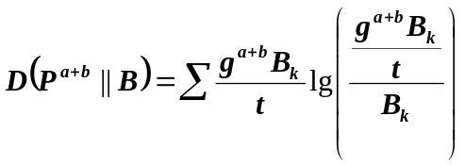

  - SP-Measure Dayhoff Scoring for Proteins
In our program we use the SP-measure along with a scoring matrix which assigns a score to the pairing of any two amino acids.

Grouping Techniques
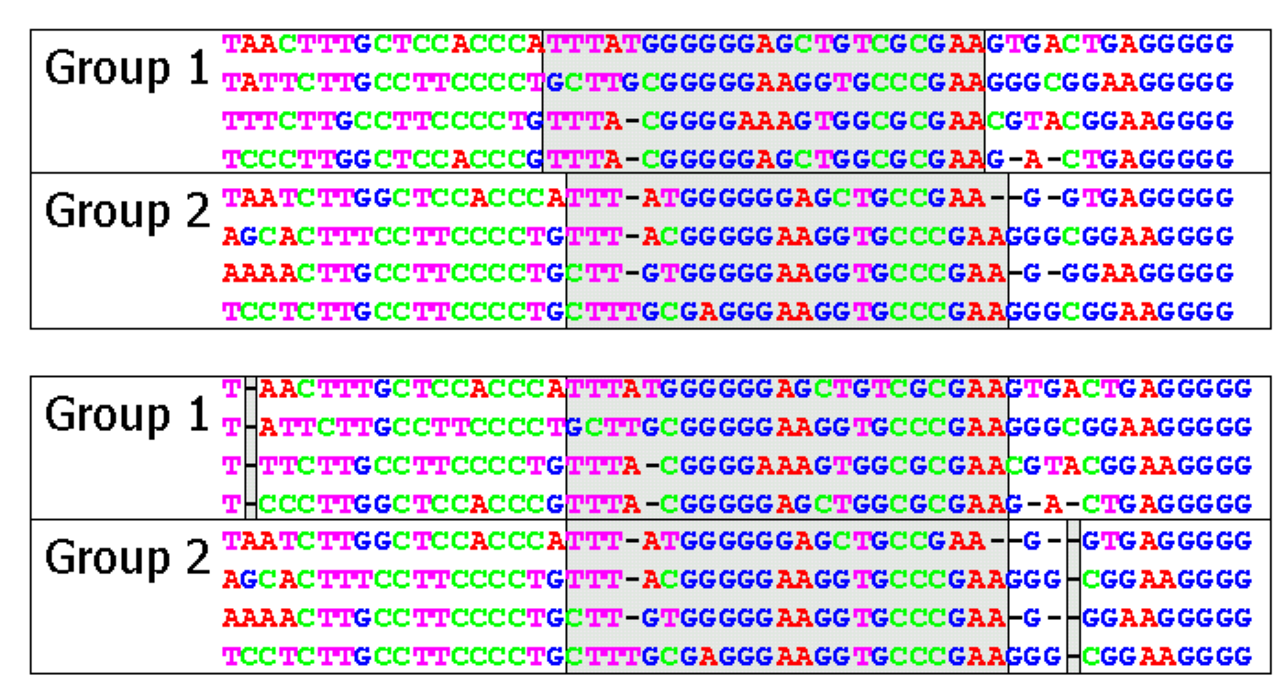

- Concluding Remarks
- Tuning Gap and Space Penalties
- Explore Effect of Local Optima
- More Advanced Grouping Methods

Created by : Kuen-Feng Huang
Date : May. 31, 2000

